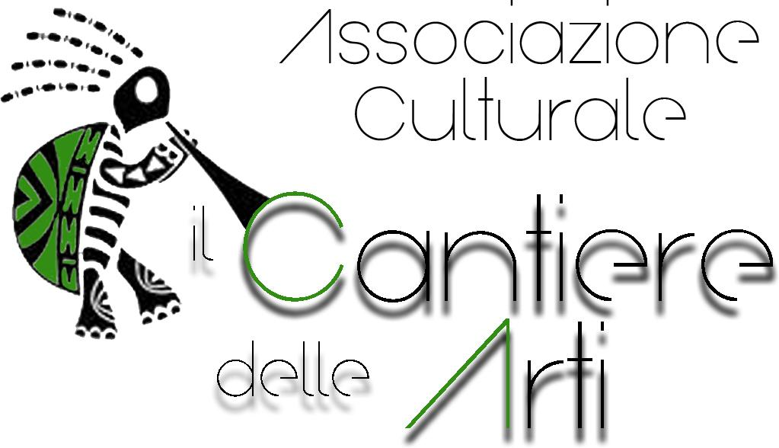

XIV International opera singing competition

“Luciano Di Pasquale”
22-24 July 2022

PRIZES COMPETITION REGULATION

Art. 1 – The XIV international opera singing competition «ArteinCanto» will take place in Teramo (TE) from 22th to 24th July 2022 at the Conservatorio Statale di Musica “Gaetano Braga” in Corso San Giorgio n.14.

Art. 2 - Lyrical singers of any nationality, age and vocal register can take part in the competition.

Art. 3 – Every competitor must bring 4 (four) operatic arias in original language and tonality. One of them should belong to Mozart's repertory.

Art. 4 – The application form must be made not over 20th July 2022 directly on our website at the following link:

www.arteincanto.it

(subject to sending the requested documentation within the established terms)

and they must contain:
- copy of a valid identity document;
- application form compiled in all parts;
- copy of proof of payment of 70€ (not refundable) that must be made through:
- bank transfer registered in Associazione culturale IL CANTIERE DELLE ARTI
IBAN: IT 93 Z 05424 76980 000000051063 - SWIFT CODE: BPBAIT3B

reason for payment: Concorso internazionale di canto lirico a premi «ArteinCanto»

In case of failed presence or if the documentation won't be conform to the regulations, the organisation won't pay back the entrance fee. Application forms arrived out of terms could be accepted by the indisputable judgement of the association.

Art. 5 -All costs of board and lodging are all depending of the students.
Art. 6 – Money prizes (1°, 2° and 3°)of competition will be assigned in any case.

PRIZES
1° Prize : 1.200€ + a concert on July 25th + 300€ * scholarship
2° Prize : 700€ + a concert on July 25th + 300€ * scholarship
3° Prize : 200€ + a concert on July 25th + € 300€ * scholarship
Scholarship for the best young singer: 200€ + a concert on July 25th
“Luciano Di Pasquale” scholarship for the best Bass-baritone: 300€ + a concert on July 25th + 200€ * scholariship

* The scholarship will be delivered only if they will perform at the concert of July 25th

Art. 7 – All competitors must arrive at 2:00 p. m. on 22th July 2022 for the nominal roll-call with an identity document and copy of the pieces to perform. Competitors who will be absent to the roll-call will be left off the competition, except for those who will arrive with justified delay. The order of performances will be set by lot.

Art. 8 – On 21th July in the Conservatorio Statale di Musica “Gaetano Braga”, a pianist will be available from 4:00 to 7:00 p.m. for an optional proof. Competitors who want to enjoy this service must book their proof by sending a message to the number of Artistic Secretariat +39. 333 9546655.

Art. 9 – Prizes competition will be structured in three stages:

- PRELIMINARY: competitor will perform ONE OPERA ARIA of his/her choice, in original language and tonality.

- SEMIFINAL: competitor will perform ONE OPERA ARIA and, eventually, ANOTHER OPERA ARIA, chosen by the jury, in original language and tonality, among those not yet performed.

- FINAL: competitor will perform TWO OPERA ARIAS chosen by the jury in original language and tonality.

COVID19: The organization reserves the right to make changes to the modalities of carrying out stages of the competition if they were to take over new health provisions on COVID pandemic 19.

Art.10 - Semifinalists by right: the competitors who have won the first three prizes of other International Singing Competitions are entitled to access the semifinal phase directly. Competitors who, having the requirements, intend to make use of this option must send a copy of the certified regulation (with the obligation of the term "International") or a diploma of merit attesting the victory in the first 3 positions attached to the application form. The copy of the certificate presented by the competitor must be from this countersigned for authentication.

Art.11 – Competitors can require the pianist provided free by the organisation or they can bring their own pianist at their own expense.

Art.12 – Jury's decisions are definitive and unappellable.

JURY

Massimiliano Becco Gagliardo (president of the jury)
Artist manager Athole Still Opera London
Corinne Baroni
Artistic Director of "Teatro Coccia" Novara
Manuela Formichella
Artistic Director of Festival ArteinCanto
Giuliano Mazzoccante
Artistic Director of "Teatro Marrucino" Chieti
Christian Starinieri
Senior Manager DM Artist Management Agency
Casting Manager IME Productions

Art.13 – Photographic services, audio or video recordings will not entail rights to compensation for the participants
Art.14 - The municipality of Bellante and the association are not responsible for damages to people or things during the competition.

USEFUL INFORMATIONS
ASSOCIAZIONE CULTURALE IL CANTIERE DELLE ARTI

Artistic secretariat
+39. 333 9546655 (You can call between 10:00 a.m. - 1:00 p. m.)
To book the proof on 21th July, send a Whatsapp message as indicated in Art.8
arteincanto@gmail.com
www.arteincanto.it
***

